# International Autonomous Robot Racing Competition 2018

## Rules v1.1

## 15 January 2018

## 1.0 Date:

The International Autonomous Robot Racing Competition (IARRC 2018) will be held on July 13th - 15th, 2018. Friday the 13th will be a practice day, with all courses available and safety inspections performed. All competition events will be held on Saturday, the 14th. In the event of inclement weather on the 15th, Sunday the 15th will be used as an alternate competition day. A detailed schedule will be provided prior to the competition.

## 2.0 Competition Objectives:

For the IARRC 2018 competition, the organizers would like to return the competition to its racing roots. We hope to focus our competition on improving the racing ability of autonomous robots, through more realistic race conditions, reduced scope of perception challenges and improved safety for both vehicles and competitors. The main challenges that will face all teams are:

1. High-speed vehicle localization
2. High-speed vehicle control (acceleration and braking) on different surfaces
3. Stop light and roadway detection
4. Collision avoidance with static objects along boundaries of course
5. Collision avoidance with other competing robots

This is Robot Racing, not Robot Wars or Urban Challenge. There will be no stop signs or traffic lights during the race (only a traffic light to signal the start of the race), and all vehicles will be required to stop safely at the end of each race and to operate throughout the race without harming or endangering other robots. The last goal will likely be the hardest, and so the competition is designed to allow teams to compete without full collision avoidance capabilities, but to award teams that perform collision avoidance well.

## 3.0 Team Eligibility:

Teams may be comprised of high school, college, undergraduate and/or graduate students, and must be supervised by at least one faculty advisor. Interdisciplinary teams are encouraged (EE, ME, CS, etc.). Only the student component of each team will be eligible for the awards. Faculty supervisor will certify that all team members are registered students. For a student to be eligible to compete as a team member, they are required to have attended at least one semester of school as a registered student between July 2017 and July 2018.

Schools can enter more than one team, but each vehicle must have a separate team of students and a distinct design report. Each entry must be based on a separate chassis and different software and must be documented by a separate application form and design report, submitted in accordance with all deadlines.

All teams who wish to enter the competition must submit a team name and provide an early bird, non-refundable registration fee of **$200.00 CAD** before **February 28th, 2018,** or a regular non-refundable registration fee of **$300.00 CAD** before **April 15th, 2018.** Please make cheques payable to **University of Waterloo**. For a complete application, your registration form must be mailed with your insurance waiver and registration fee to:

Prof. Steven Waslander

IARRC 2018

Department of Mechanical and Mechatronics Engineering

University of Waterloo

200 University Ave.

Waterloo, ON, Canada

N2L 3G1

Receipts will be issues as soon as the cheques are processed and returned to the team leader by email. The registration and intent to compete forms are available on the Robot Racing website at <http://robotracing.wordpress.com/registration/>.

## 4.0 Vehicle Requirements:

The competition is designed for a small semi-rugged outdoor vehicle. All competing vehicles must satisfy the following requirements:

|  |  |
| --- | --- |
| **Length** | The vehicle must not exceed a maximum length of 75 cm. |
| **Width** | The vehicle must not exceed a maximum width of 55 cm. |
| **Height** | The vehicle must not exceed a maximum height of 60 cm. |
| **Weight** | The vehicle must not exceed a maximum weight of 20 kg. |
| **Propulsion** | The vehicle must be propelled entirely by battery power. No liquid combustible fuel storage systems are allowed. |
| **Mechanical E-Stop** | A mechanical E-Stop must be present with a red button at a minimum height of 30 cm. The mechanical E-Stop must completely disable the vehicle’s drivetrain by cutting power to the motor(s). |
| **Wireless E-Stop** | The wireless E-Stop must operate over a minimum range of 50 feet. The wireless E-Stop must stop the vehicle’s motion within 5 seconds. |
| **Markings and Interference** | The vehicle must not interfere with other vehicles’ sensing or navigation abilities, cannot have any markings that could confuse other vehicles (orange cone or white lines), and cannot contain any RF interference devices. This requirement will be assessed by the judges at the time of qualification. |
| **Autonomy** | The vehicle must be able to drive in a straight line at a constant speed of 2 m/s for 10 m and come to a stop within 5 m. |
| **Maximum Speed** | The vehicle must be hardware limited to operate up to 10 m/s maximum. |

## 5.0 Safety Qualification:

Each vehicle must pass the safety qualification in order to compete in either the drag or the circuit race. Only qualified vehicles will be eligible for awards in any of the three competitions. The qualification process will require demonstrating all vehicle requirements to the judges, and can be attempted as many times as desired while qualification is open, as stated in the official competition agenda (to be released). For the autonomy requirement, teams can mark the straight line path using cones, walls or lines, which will be available on site.

## 6.0 Weather

The drag and circuit races will be held outdoors, unless the course is considered too wet by the judges or there is heavy rain. The drag and circuit races will continue in light rain. Vehicles should be prepared to operate in light rain and traverse small puddles. In the event of heavy rain on the first competition day (July 14th), races will be postponed until the following day (July 15th). In the event of heavy rain on both the 14th and 15th, races will be held indoors in the University of Waterloo Live Link Room on the 15th.

## 7.0 Driving Rules

**7.1 Traffic Light:**

A traffic light signal will be used to signal the start of both the drag and the circuit race, located 30cm above and 2.0m in front of the vehicle start line facing the direction of vehicle movement. In the Drag Race, the light will be positioned in the middle of the track, as indicated in Figure 1. In the circuit race, the traffic light will be positioned on the right side of the course. The light will be red initially, and will switch to green to signal the start of the race, and remain green until the next race start. Vehicles will be required to detect when the traffic light turns green. Each false start will result in a 1.2 multiplier penalty being applied to the final time. The traffic light part number is NBB100RG.

**7.2 Course departure: evices. ent of the vehicle may impede or interfere with the preformance**

A vehicle must remain within the course boundaries defined for both the drag and circuit races below. A 1.2 multiplier penalty will be applied to the final time for every excursion from the course during the circuit race and a 1.5 multiplier penalty applied during the drag race. Team members can reset the vehicle on the course and must replace any displaced objects.

**7.3 Pit Stops:**

If a robot becomes disoriented or immobilized, the team may make an emergency pit-stop. A 1.1 multiplier penalty will be applied to the final time, and the robot may be placed back at the position where the pit stop was requested to continue with the race. Pushing the robot for a boost will not be permitted. Unlimited pit stops are permitted, though the timer will continue to run.

**7.4 Accidents or Collisions:**

Collisions between the vehicles may occur during the drag or circuit race. A robot will be considered 'at fault' in a collision if it hits another robot from behind, or it appears to have lost control and hits another vehicle. If judged at fault in a collision, a 1.5 multiplier penalty will be applied to the final time for the circuit race and a 2.0 multiplier will be applied during the drag race. The judges will decide if the vehicle at fault will be allowed to continue or poses a risk to the other vehicles. If unfit to continue, the team will be counted as not finishing (DNF), time will be recorded and penalties will be applied.

**7.5 Lack of progress:**

Vehicles stopping on the course for over 30 seconds without cause or driving in the wrong direction will be paused and taken out of the race and will only be allowed back if they are deemed fit to continue by one of the judges. Both infractions will result in a 1.1 multiplier penalty applied to the final time. If unfit, the team will be counted as not finishing (DNF), time will be recorded and penalties will be applied.

**7.6 Penalty Summary:**

Penalties incurred during the drag race and circuit race are cumulative multipliers. Due to differences in difficulties, the multipliers are different for drag and circuit races. In the event of multiple penalties being applicable (driving off course and striking cones), the single worst penalty shall be applied.

|  |  |  |  |  |  |  |
| --- | --- | --- | --- | --- | --- | --- |
| **Penalty** | False Start | Lane Departure | Vehicle Collision  (At fault) | Cone Collision | Pit Stop | Lack of Progress |
| Drag Race | 1.2 | 1.5 | 2.0 | 2.0 | 1.1 | 1.1 |
| Circuit Race | 1.2 | 1.2 | 1.5 | 1.5 | 1.1 | 1.1 |

Times will be counted for the races as follows:

**TimeTeam = Timeraw*Π(penalties)**

In the case of not finishing the race (DNF):

**Timeteam = Timeraw*Π(penalties) / (% course complete)**

Scores will be calculates as follows:

## Score = 100-50*sqrt((Timeteam- Timelowest)/( Timehighest - Timelowest))

## 8.0 Drag Race

A fully autonomous unmanned ground robotic vehicle must race against one other vehicle on a straight, outdoor track. In the event of rain, the Drag Race will be held indoors in the Student Design Center. The track surface may be asphalt (outdoor) or concrete (indoor due to rain). Vehicle operation throughout the drag race all the way to a complete stop must be autonomous.

**8.1 Course Boundary**

The (approximately 60 m) track will consist of two parallel lanes, with orange cones (9” Cones <http://bit.ly/IARRCcones> ) marking the outsides of both lanes. A solid Magenta line marks the start and finish. There will be a white center line between the lanes. All lines in the drag race course will be created using solid colored duct tape. Cones will be placed no more than 1m apart and no less than 0.5m apart. The lane width will be at least 1.5m. A brake zone will be created at the end of the drag race which is at least 6m long and ends in a cardboard box wall at least 30 cm high. Each vehicle is required to stay within its lane for the duration of the drag race and come to a complete stop before the end of the brake zone (see driving rules above for penalties). The outdoor course will be located on the University of Waterloo campus in the Q parking lot (approximate GPS coordinates 43°28'28.3"N 80°32'26.1"W).

a)

b)

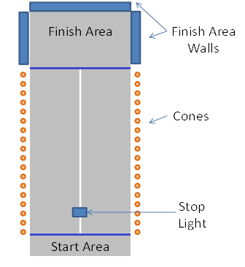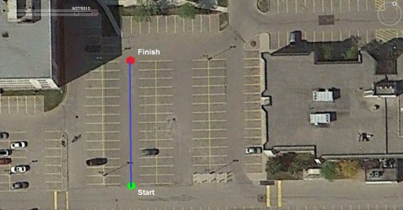

Figure 1: a) Drag race location denoted by blue line. b) Schematic of drag race setup.

## 9.0 Circuit Race

A fully autonomous unmanned ground robotic vehicle must race against three other vehicles on a winding, outdoor course. The course surface may be asphalt, concrete or stone tile (outdoor) or concrete and wood or carpet (indoor due to rain on both competition days). The course may contain slopes up to 10 degrees. The course boundary will be denoted by solid white lines on the inside of the course and solid yellow lines on the outside of the course.

Each vehicle will get the chance to perform a single qualifying lap, and start position in the circuit race will be determined by single lap finishing time, following by distance traveled around the course. The circuit race will consist of three laps, and will have a maximum of four competitors on it at one time. Heats will be run as needed, with the top vehicle in heat one, the second in heat two etc. until all heats are filled up. The top two cars from each heat will advance to the next round, until only four vehicles remain for the final. Ranking will be determined based on time of completion in the last heat reached, or if incomplete, on distance traveled around the course.

**To receive any prizes, a team’s robot *must* complete a full lap around the circuit course.**

## 9.1 Course Boundary and Features:

The circuit course boundary will be marked as depicted in the figure below. The lane width will be at least 1.5m, nominally 2m, and no more than 3m. The starting position is marked by the green circle, and the race will proceed in a clockwise fashion. Solid yellow lines will mark the outer boundary of the course on all asphalt surfaces and solid white lines will mark the inner boundary on all asphalt surfaces. The start/finish line will be marked by a solid magenta line. All lines will be comprised of solid duct tape of the appropriate color. Outer and inner line thicknesses will be approximately 2” and the start/finish line will be 6” thick. Cones (9” Cones <http://bit.ly/IARRCcones> ) will mark the course on both the inside and outside of the course in difficult areas. Existing road lane markings painted on the asphalt that are within the course boundaries and deemed significantly distracting will be covered with dark grey outdoor carpet.

There will also be a secondary path marked on the map in Purple which provides a shortcut on the course. It will require the navigation of multiple acute turns, but provide a significant distance advantage. Cones will mark the entrance and exit to the short cut. The course will be located in the parking lot behind Engineering 5.

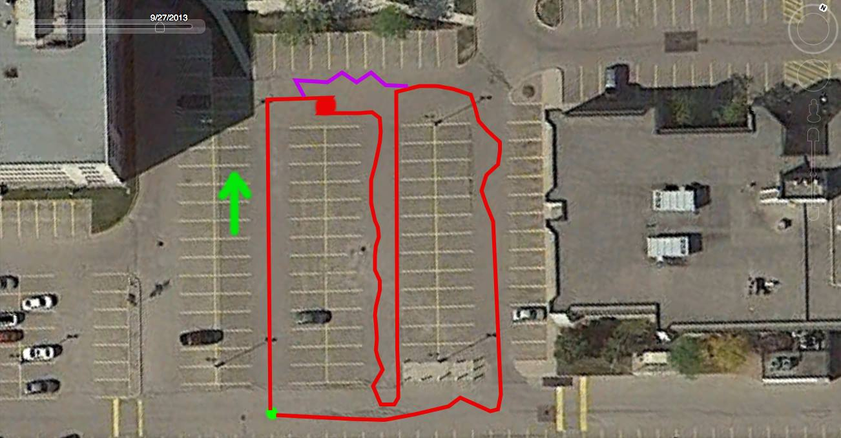

Figure 2: Circuit course overview

## 10.0 Design Competition

**10.1. Written Report**

The report should not exceed 8 letter-sized pages and use IEEE two-column conference format (<http://www.ieee.org/conferences_events/conferences/publishing/templates.html>). Line spacing must be at least 1.5, with at least a 10 point font. Each vehicle must have a distinct and complete report of its own. Participants are required to submit an electronic copy via e-mail by 5pm EST July 3, 2018. The electronic copy of the report will be posted on the competition's web site in PDF format after the completion of the competition.

The report should present the conceptual design of the vehicle and its components. Especially important to highlight are any unique innovative aspects of the design and the intelligence aspects of the vehicle that address the 5 main challenges described above in the Competition Objectives.

|  |  |
| --- | --- |
| **Judges will score the written reports as follows:** | **Maximum Points** |
| Effective innovation represented in the design | 20 |
| Completeness of solution to the competition objectives | 10 |
| Completeness of experimental results | 10 |
| Style (Language, Figures, Structure, Clarity) | 10 |
| **Total** | **50** |

**10.2. Oral Presentation**

The technical talk should relate the highlights of the written report described above and include any updates of the design since the written report. The presentation must be made by one or more student members of the team to the judges and other interested members of the audience and should last no more than 10 minutes. After the presentation, judges and general audience may ask questions for up to 5 minutes. A Windows 7 laptop with Adobe Reader and Powerpoint, and a projector will be made available.

|  |  |
| --- | --- |
| **Judges will score the oral presentations as follows:** | **Maximum Points** |
| Clear and understandable explanation of the innovations | 20 |
| Experimental results | 10 |
| Response to questions | 10 |
| Style | 10 |
| **Total** | **50** |

**10.3. Videos**

Every participating team is required to submit a video, as part of a critical design review. The purpose of the video is to summarize the team’s progress, and prove that the team is on track to have a fully functioning robot in time for the competition. The videos will be capped at 3 minutes, and are due on April 30, 2018 11:59pm EST.

|  |  |
| --- | --- |
| **Judges will score the oral presentations as follows:** | **Maximum Points** |
| Awesomeness of video (quality, editing, visual appeal) | 20 |
| Robot racing demonstrations | 20 |
| Explanations of technical innovations | 10 |
|  |  |
| **Total** | **50** |

## 11.0 Award

The Award trophies will be presented to the top three teams that perform the best overall (combined scores per below), in all three competitions. For each competition, points will be awarded to each team, below is a breakdown of the points:

|  |  |
| --- | --- |
| **Competitions** | **Maximum Points** |
| Drag Race | 100 |
| Circuit Race | 200 |
| Design Competition | 100 |
| **TOTAL** | **400** |

**To receive any prizes, a team’s robot *must* complete a full lap around the circuit course.**

## 12.0 Disclaimer

The IARRC Committee and Officials will try to adhere to the above official competition details, rules and format as much as possible. However, it reserves the right to change or modify the competition where deemed necessary for preserving fairness of the competition. Modifications if any will be announced as early as possible prior to the competition.